**HA NOI UNIVERSITY OF SCIENCE AND TECHNOLOGY**

**BACHELOR THESIS PROJECT**

**Serving Mobile Robot For Restaurant**

**Firmware Design**

**LY DUC TRUNG**

trung.ld181930@sis.hust.edu.vn

**Ngành Kỹ thuật điện**

**Chuyên ngành Hệ thống điện**

|  |  |
| --- | --- |
| **Supervisor:** | Le Minh Thuy, Ph. D  Chữ ký của GVHD |
| **Department:** | Instrumentation and industrial informatics |
| **School:** | School of Electrical & Electronics Engineering |
| **HA NOI, 08/2022** | |

**ĐỀ TÀI TỐT NGHIỆP**

Biểu mẫu của Đề tài/khóa luận tốt nghiệp theo qui định của viện, tuy nhiên cần đảm bảo giáo viên giao đề tài ký và ghi rõ họ và tên.

Trường hợp có 2 giáo viên hướng dẫn thì sẽ cùng ký tên.

Giáo viên hướng dẫn

Ký và ghi rõ họ tên

**Lời cảm ơn**

Đây là mục tùy chọn, nên viết phần cảm ơn ngắn gọn, tránh dùng các từ sáo rỗng, giới hạn trong khoảng 100-150 từ.

**Tóm tắt nội dung đồ án**

Tóm tắt nội dung của đồ án tốt nghiệp trong khoảng tối đa 300 chữ. Phần tóm tắt cần nêu được các ý: vấn đề cần thực hiện; phương pháp thực hiện; công cụ sử dụng (phần mềm, phần cứng…); kết quả của đồ án có phù hợp với các vấn đề đã đặt ra hay không; tính thực tế của đồ án, định hướng phát triển mở rộng của đồ án (nếu có); các kiến thức và kỹ năng mà sinh viên đã đạt được.

Sinh viên thực hiện

Ký và ghi rõ họ tên

**TABLE OF CONTENTS**

CHAPTER 1. GENERAL INTRODUCTION ABOUT MOBILE ROBOT 1

1.1 Overall information about mobile robots 1

1.1.1 Mobile Robot Introduction 1

1.1.2 Mobile robot in service delivery 2

1.2 Serving mobile robot design planning 6

1.2.1 Design planning of project 6

1.2.2 Scopes of work 7

CHAPTER 2. GENERAL HARDWARE DESIGN FOR SERVING MOBILE ROBOT 8

2.1 Hardware components 8

2.1.1 Raspberry Pi 4 8

2.1.2 ESP32 microcontroller 8

2.1.3 Motors 8

2.1.4 Motor driver 8

2.1.5 Encoders 8

2.1.6 Ultrasonic sensors 8

2.1.7 Lidar 8

2.1.8 Inertial measurement unit 8

2.1.9 OLED display 8

2.1.10 Infrared sensor 9

2.1.11 Voltage sensor 9

2.2 Hardware structure design 9

CHAPTER 3. ROS 2 FRAMEWORK FOR DEVELOPING ROBOTS 9

3.1 Robot software platforms 9

3.2 The basis for selecting ROS 10

3.3 The change of the ROS version 10

3.4 ROS 2 introduction 13

3.4.1 Communication 14

CHAPTER 4. FIRMWARE DESIGN FOR SERVING MOBILE ROBOT 14

4.1 Raspberry Pi 4B configuration 14

4.1.1 Ubuntu version 14

4.1.2 zRAM 15

4.1.3 ROS 2 Galactic 16

4.1.4 Multiple I2C buses 16

4.2 Serving mobile robot firmware architecture 16

4.3 Firmware for motor driver block 17

4.3.1 Choosing sample time of encoders 17

4.3.2 Firmware for ESP32 microcontroller 17

4.4 Firmware for ultrasonic sensors 23

4.5 Firmware for lidar 23

4.6 Firmware for inertial measurement unit 24

4.7 Firmware for OLED display 24

4.8 Firmware for infrared sensor 24

4.9 Firmware for voltage sensor 24

CHAPTER 5. ALGORITHM EXPLANATION FOR FIRMWARE 24

5.1 PID controller 24

5.2 Fuzzy logic library 24

5.3 Kinematic Model for calculating Odometry data 24

5.4 Kalman filter 24

5.5 Median filter 24

CHAPTER 6. OPTIMIZATION 24

6.1 Object oriented programming 24

6.2 Multithreading programming 24

CHAPTER 7. EXPERIMENTAL RESULTS 24

7.1 Comparison of PID controller and Fuzzy PID controller 24

7.2 Obstacle avoidance using an array of ultrasonic sensors test cases 24

7.3 Restaurant serving test cases 24

7.4 Serving mobile robot design result ? 24

REFERENCES 26

APPENDIX 27

**DANH MỤC HÌNH VẼ**

Figure 1: Scheduling latency in an idle environment. (a) ROS 1.0 (b) ROS 2.0 [3] 11

Figure 2: Scheduling latency in a stressed environment (a) ROS 1.0 (b) ROS 2.0 [3] 12

Figure 3: Maximum communication latency given the data size in environments with network traffic 13

Figure 4: System requirements from official website for ROS 2 Galactic Geochelone 14

Figure 5: Ubuntu 20.04.4 LTS on Raspberry Pi 4 15

Figure 6: Initial amount of RAM on Rapsberry Pi 4 15

Figure 7: No-load performance of RAM on Raspberry Pi 4 15

Figure 8: Motor driver block 17

Figure 9: Flowchart of setup() function for EPS32 firmware 18

Figure 10: Flowchart of loop() function for EPS32 firmware 19

Figure 11: JSON form of receiving data of ESP32 microcontroller 19

Figure 12: Commonly­used Frequencies and Resolutions 20

Figure 13: Flowchart of driveMotors() function for EPS32 firmware 20

Figure 14: H-SW Control Function of TB6612FNG motor driver 21

Figure 15: Solution for instantaneous operating of motors 21

Figure 16: RPMCalculator class 22

Figure 17: Transmission speed and Real transmission speed of serial port 22

**DANH MỤC HÌNH VẼ**

Bảng 1.1 Thống kê các thiết bị và giá thành 12

# GENERAL INTRODUCTION ABOUT MOBILE ROBOT

## Overall information about mobile robots

### Mobile Robot Introduction

Throughout history, the idea of mechanical automata that can resemble or replace human activities has originated in the mythologies of many cultures around the world. However, this becomes more popular in the 19th and especially 20th century. A machine with the ability to carry out a complex series of actions automatically is called robot. Mobile robot is a robot that is not attached to the environment and is able to move in a certain surrounding space.

A mobile robot can be designed with an autonomous system, which can self-navigate within their environment or relies on guidance devices to follow a pre-defined route. The autonomy of the mobile robot must be guaranteed with aspects of energy and self-making decision. The level of autonomy can be defined based on the commands of human operator, from operate with desired wheel velocities to achieve desired robot longitudinal and angular velocities, follow path or trajectory to self-operate inside of the known or unknown environment.

The hardware structure of mobile robot is a combination of mechanical and electronic parts, mainly:

* Mechanical parts: rigid and moving parts (body, wheels, etc.)
* Actuators: electrical motors (DC, stepper, servomotor, etc.)
* Sensors: rotation encoders, lidar, ultrasonic sensors, accelerometer & gyroscope sensor, etc.
* Computers:  micro-controllers, embedded computer, …
* Power unit: batteries, solar panels, …

Related to the working environment, mobile robot can be classified into three principal groups:

* Ground mobile systems: They are designed to operate on the ground and included various platform such as mobile vehicles with wheels or caterpillar, legged robots or mimic some other type of animal locomotion.

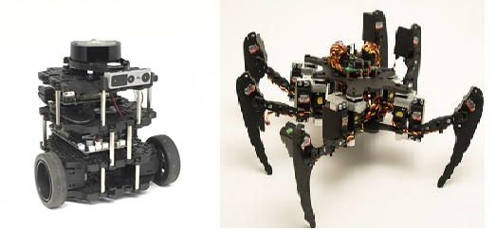

* Aerial mobile systems: This group consists of systems that can fly in a certain aerial space or orbit the Earth.

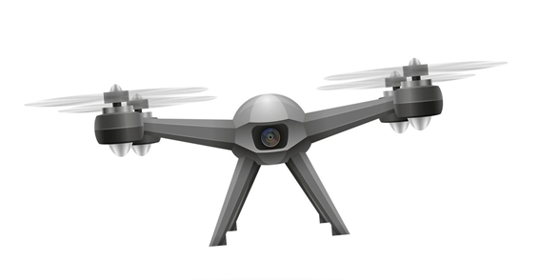

* Water and under water mobile system: We can find many kinds of ships, boats, submarines, autonomous underwater vehicles, etc.

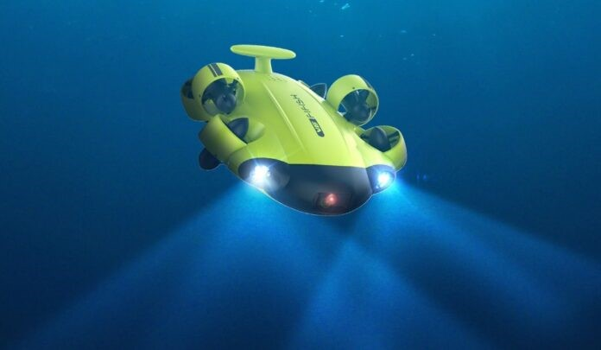

Nowadays, with the rapid development of technology, mobile robot is gradually applied to replace human activities in various fields, especially in hazardous or inaccessible environments (planets, minefields, radioactive environments, etc.). Moreover, applying robot in production can also help human to reduce labor costs, and increase productivity. The application field of mobile robot is expanded day by day namely medical service, operation support, cleaning applications, consumer good stores, military and security, etc. It can be concluded that in the near future, mobile robots can become a part of our life with a great support from household chores to discover unknown planets.

### Mobile robot in service delivery

Different from industrial application where the role of robot is to replace humans for carrying out dangerous tasks in hazardous environment, robots for service are more likely to assist humans for working. We can easily find the support of mobile robot in many aspects such as hospitality, agriculture or education. Another application of mobile robot must be mentioned is to deliver goods. The general function of robot in this application is to carry a payload from a source to its destination. With the support of mobile robot, human can focus on higher value activities. The problem of labor shortage for low-value tasks can also be solved and productivity is also increased because robots don’t need breaks or downtime.

One significant example of using robot in delivery is for restaurants where they can deliver food to the table and carry dirty dishes back to the kitchen. Many technology companies are racing to implement their own delivery robots to meet the zooming upward demand day by day. Below are some design models of serving robot in the market.

“Servi”: “Servi” is a production of Bear Robotics, a robotics and artificial intelligence company, and SoftBank Robotics Group.

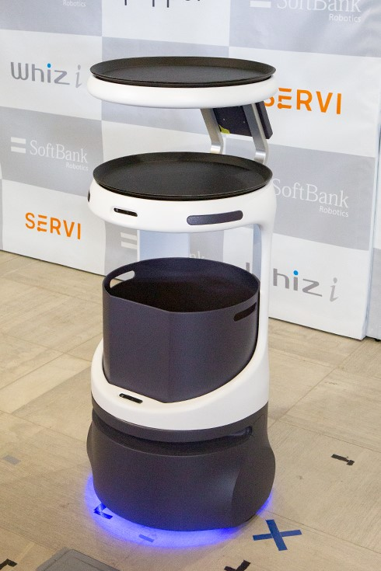

“Servi” can autonomously travel and carry food when customer select a table to serve on the screen. It can also move while detecting and avoiding obstacles such as people and objects with high accuracy. “Servi” is said to improve the efficiency of the establishment and the quality of customer service. 

|  |  |
| --- | --- |
| ***Main specs*** | ***Value*** |
| Maximum Load Weight | 35kg |
| Navigation Method | SLAM |
| Sensor | LiDAR, 3D Camera |
| Communication | Wi-Fi 2.4/5 GHz |
| Working time | 8 – 12 hours/single charge |
| Maximum speed | 0.6 m/s |
| Rental fee | 738 USD/month |

Beside “Servi” robot, many other robotics company also introduced their invention of serving robot.

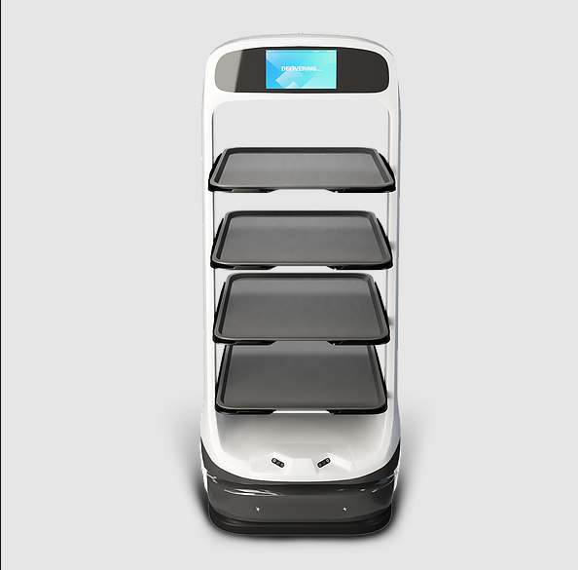

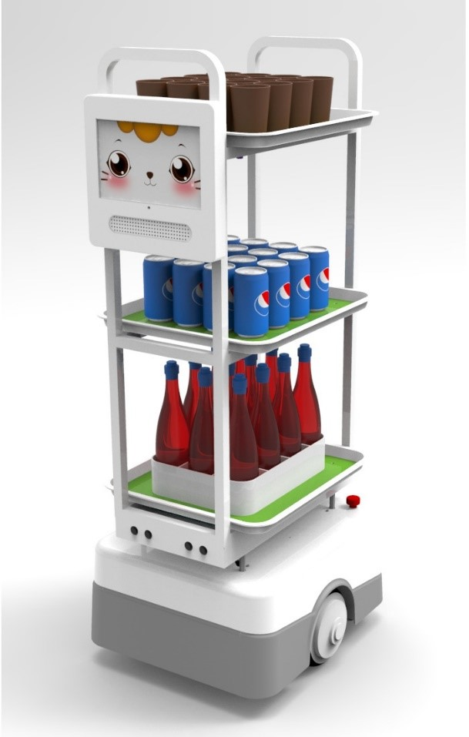

These robots’ design shares the same technologies which will be described in detail below:

* Sensors: To localize and navigate, several range sensors, cameras, and radars can be added. One of the most popular sensors that are used in mobile robot is a LIDAR (Light Detection And Ranging), which is normally set up on the top of the robot to achieve maximum coverage. The point cloud produced by the LIDAR sensor contains a huge amount of data about the surroundings. To distinguish, categorize, and identify the objects from the raw point cloud data, advanced data processing is used. Additional sensors like radar or ultrasonic sensors are also added to improve the preciseness about the environment. They are implemented to measure the distance and detect near obstacles around the robot. Besides that, to enable the calculation for odometry, rotation encoders are equipped with robot’s motors. Some other sensors like accelerometers, gyroscopes are also attached on the robot to measure navigation tasks.
* Localization and mapping: Many features can be used to solve these tasks. The recent modern solution becoming more and more popular is using Simultaneous Localization And Mapping method (SLAM) – the method of constructing or updating a map of an uncharted area while keep tracking robot’s position.
* Communication: Wireless technology is used by many mobile robot platforms to connect with other robots, human machine interfaces, and off-line computing resources. Numerous mobile robots are outfitted with wireless technologies including Bluetooth, Wi-Fi, Wireless LAN, and others.
  + Wi-Fi or Wireless LAN: Wireless Local Area Networks, often known as Wi-Fi or WLAN, are based on a set of specifications known as 802.11 from the Institute of Electrical and Electronics Engineers (IEEE). Wi-Fi operates mostly in the unlicensed 2.4GHz spectrum of radio frequency. It makes it possible for someone to use a wireless access point to connect to the Internet using a computer or PDA that supports wireless. A hot spot is the geographic area that one or more access points cover. Wi-Fi is increasingly often utilized for Internet access outside despite being designed for mobile devices and local area networks. ControlNet: ControlNet employs a single media link with (cheap) RG-6 coaxial cables and a bus. It is built on its own physical and data link layer. It has up to 99 nodes, a 5 Mbit/s throughput, data upload/download, and P2P communication.
  + Bluetooth: Most wireless technologies, including Bluetooth and the IrDA standard, provide users the option of bolstering their local wireless network. In the workplace, in labs, or at home, Bluetooth technology, developed by Ericsson in 1994, is utilized in place of wires. a wireless technology that uses a short radio frequency cable. (2012) IACSIT Press, Singapore, IPCSIT vol. 34, International Conference on System Engineering and Modeling (ICSEM 2012) The scientific community is moving distance to 2.4GHz bandwidth to replace unlicensed equipment. Broadband 1 MB per second speech and data exchanges are supported via Bluetooth devices, which typically have a range of around 10 meters. Parts of Bluetooth have been included into a variety of mobile devices, including mobile phones, PDAs, and other wireless equipment, because of Bluetooth's benefits, including inexpensive prices, low power consumption, and nature may be turned in different directions. Around 200 million Bluetooth devices will be sold in 2001, according to research by In-Stat/MDR and Frost & Sullivan, and one billion in 2006. As a result, Bluetooth technology is now being used for mobile robot controllers.

## Serving mobile robot design planning

### Design planning of project

The market for autonomous delivery robots is still at the beginning. One drawback limiting applications of service mobile robot is the high cost for renting or buying. Therefore, in this project, our purpose is to design a mobile robot for restaurants with the ability to self-navigate and can totally replace the role of servant to serve food or drink to customers. Modern technologies and system are integrated in the robot design, but still ensure the suitable price.

Serving mobile robot specification:

* Sensor: LiDAR, Ultrasonic sensor, IMU.
* Navigation method: SLAM.
* Communication: Wi-Fi.
* Body weight: kg.
* Maximum load weight: kg.
* Maximum speed:  m/s.

### Scopes of work

#### Analysis & decision making

This is the first step of designing a mobile robot. General plans for designing the robot structure are outlined, together with researching hardware components which is available on the market and suitable for robot using’s purpose.

#### Hardware design

After analysis to get the design planning, the hardware of robot is begun with calculation of main mechanical and electronic parts.

Scopes of work include:

* Mechanical design: Consider the kinematic model to design robot’s frame and do the calculation to select suitable actuators (DC motor).
* Electronic system design: Select and combine electronic devices: power supply, sensors, computers, actuator drive, … to complete the robot electronic system. Design the motor controller for controlling speed of the robot.

#### Firmware design

System firmware is designed to combine the data taken from peripherals and preprocess all those data using algorithms.

* Sensors: Configure multiple I2C buses in Raspberry Pi 4. Read data from sensors and create Nodes for communicating between ROS 2 and all the sensors.
* Motors: Configure communication method between ESP32 and Raspberry Pi 4 to control the motors and receive data from encoders.
* Algorithms:
  + Program PID controller in Python for driving motor.
  + Program Fuzzy Logic library in C++ for PID controller.
  + Program Kalman Filter and Median Filter in Python for sensors.
  + Program Kinematic Model for calculating Odometry data of the robot.

#### Software design

Mainly work with ROS 2 framework and focus on improving and customizing Navigation Stack for the robot, which includes tasks:

* Create 3D model of robot and restaurant environment for simulation tests. Build transform frame, which represents the position and orientation of different robot's parts corresponding to each other and to the map frame when robot moves.
* Mapping environment with SLAM.
* Localize the robot on the map based on data from odometry, imu sensor and lidar.
* Plan path around obstacles and control the robot as it follows the planned path.
* Convert sensor data into a 2d costmap representation of the robot’s surrounding world.
* Create robot’s operation flow using behavior trees.

#### Experiment & results

The result of speed controller for robot by Fuzzy PID is analyzed and compared with classic PID controller.

Several specific serving cases for robot are also implemented in real life to evaluate working performance of the robot.

# GENERAL HARDWARE DESIGN FOR SERVING MOBILE ROBOT

## Hardware components

### Raspberry Pi 4

### ESP32 microcontroller

### Motors

### Motor driver

### Encoders

### Ultrasonic sensors

### Lidar

### Inertial measurement unit

### OLED display

### Infrared sensor

### Voltage sensor

## Hardware structure design

# ROS 2 FRAMEWORK FOR DEVELOPING ROBOTS

## Robot software platforms

Platforms have recently attracted more interest in the robotics community. Hardware platforms and software platforms both have their own subcategories. A robot software platform consists of the tools needed to create robot application programs, including hardware abstraction, low-level device control, sensing, recognition, SLAM (simultaneous localization and mapping), navigation, manipulation, and package management, libraries, debugging, and development tools. Software platforms have made it possible for many individuals to contribute to the creation of robots, and robot hardware is now being created using the interface that software platforms give.

The smartphone field and the robot field are advancing along the same path. The robot software platform is in a dynamic stage where anybody may become the market leader, even if there is still more to be done compared to the smartphone operating system.

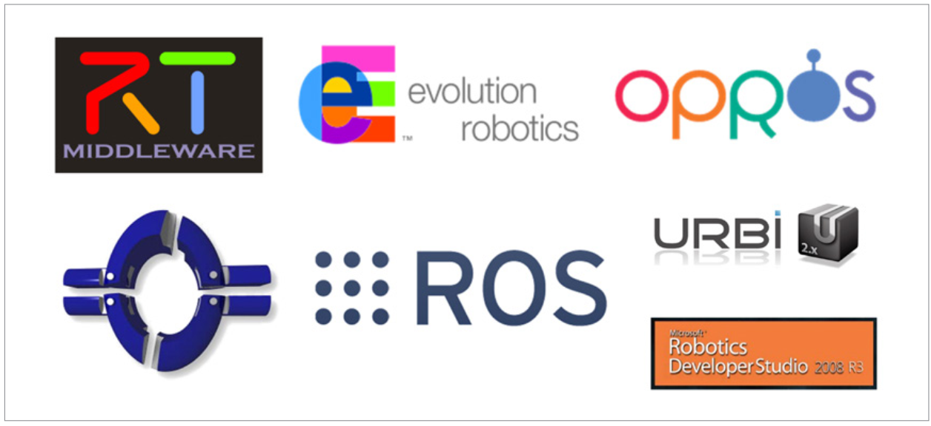

The most popular robot software systems are those that are listed below:

* ROS: Robot Operating System, Open Robotics - U.S.
* OpenRTM: National Institute of Adv. Industrial Science and Technology (AIST) – Japan.
* ERSP: Evolution Robotics Software Platform, Evolution Robotics – Europe.
* OPROS: ETRI, KIST, KITECH, Kangwon National University - South Korea.

## The basis for selecting ROS

ROS is a robot software platform which helps to reduce the developing and programming time. By entering a few standardized codes, one may quickly convert a non-ROS system to a ROS system without having to completely rewrite the system and programs. Additionally, ROS offers a variety of widely used tools and software and enables users to concentrate on the things they are interested in or would want to contribute to, which eventually cuts down on the time required for development and maintenance.

* The program can be reused: A user may concentrate on the feature they want to build and get the matching package for the other functionalities. They may also reuse the application they created by sharing it with others.

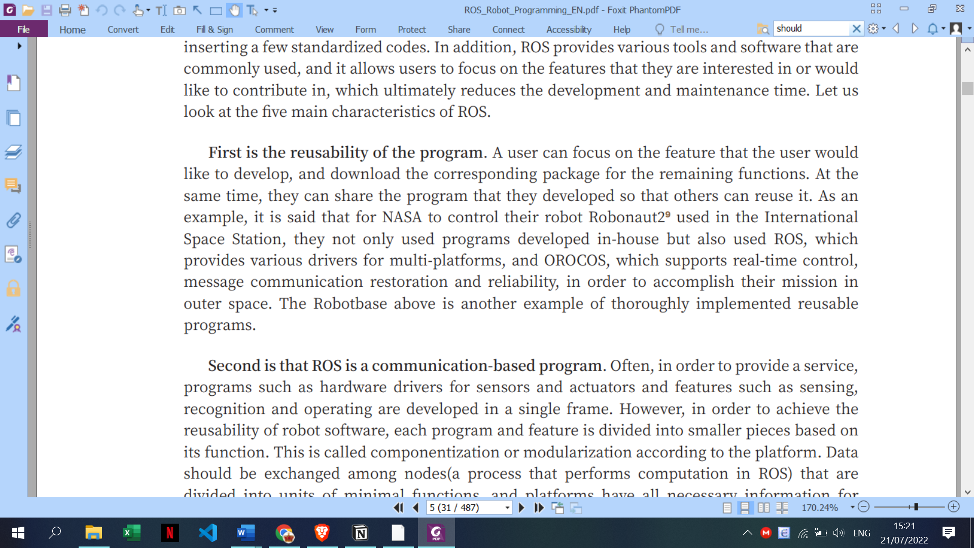

<nói them ban đầu làm ROS 1 xong về sau chuyển sang ROS 2>

## The change of the ROS version

While the robot and humans share the same workspace in real time, if there are any system latency-related problems, the user might sustain bodily harm. In order to ensure reliable functioning, real-time limitations must be met. Researchers have suggested a number of methods to enable ROS to operate in real-time because it does not currently carry out these requirements. Data Distributed Services (DDS) was designed as middleware for internal communication in ROS 2.0 to facilitate real-time communication. Data is sent via the Real-Time Publish-Subscribe (RTPS) protocol, multicasting, and connectionless transmission techniques like UDP/IP.

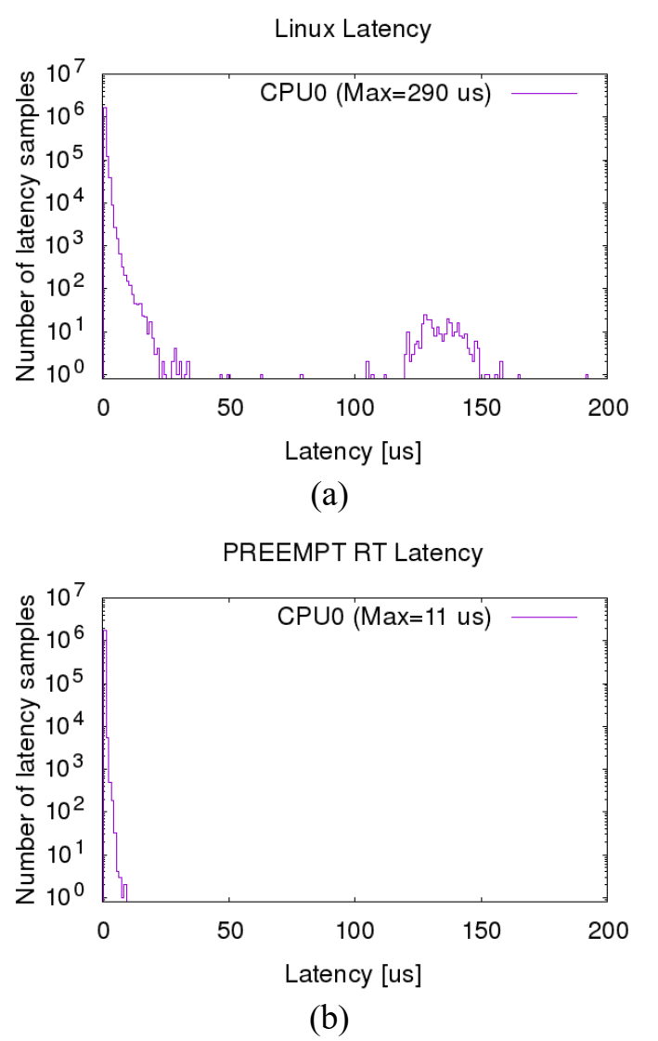

Figure : Scheduling latency in an idle environment. (a) ROS 1.0 (b) ROS 2.0 [3]

As can be observed, the recorded maximum latency, which is 290 us as opposed to ROS 2.0's 11 us, is much greater. The ROS 1.0 findings also display a wider distribution than the ROS 2.0 results, where the majority of the measured data samples are clustered below the highest value. As a result, ROS 2.0 enabled deterministic behavior and more effectively fulfilled the strict temporal requirements than ROS 1.0. Additionally, ROS 1.0 operated inconsistently since it had a wider spread than ROS 2.0. As a result, the ROS 2.0 system worked steadily and offered better real-time performance than ROS 1.0.

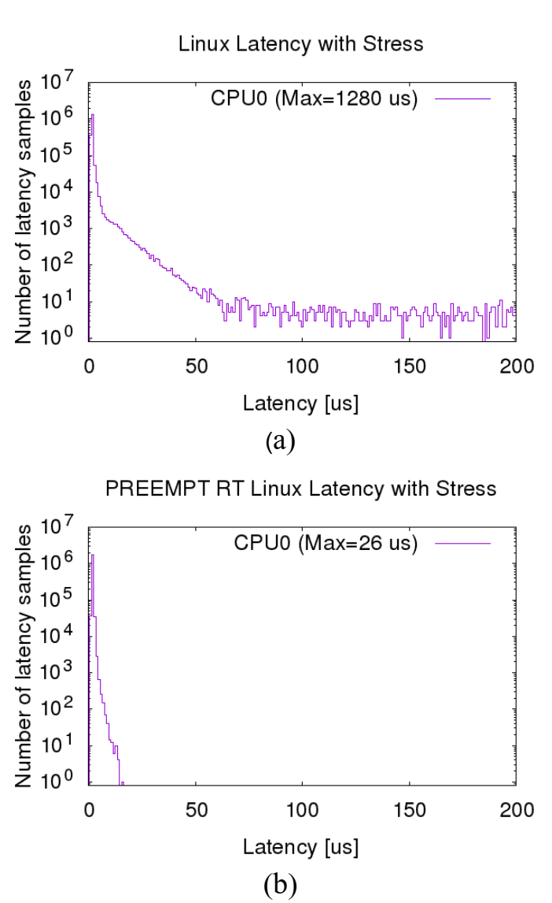

Figure : Scheduling latency in a stressed environment (a) ROS 1.0 (b) ROS 2.0 [3]

The greatest delay for ROS 1.0 and ROS 2.0, respectively, was estimated to be 1280 us and 26 us. The maximum latency was higher for both the ROS 1.0 and ROS 2.0 systems when compared to the findings of the performance assessments in idle situations. In this instance, the 1 ms deadline was not met by ROS 1.0. However, ROS 2.0 was still able to achieve the deadline despite with a modest increase in the maximum latency.

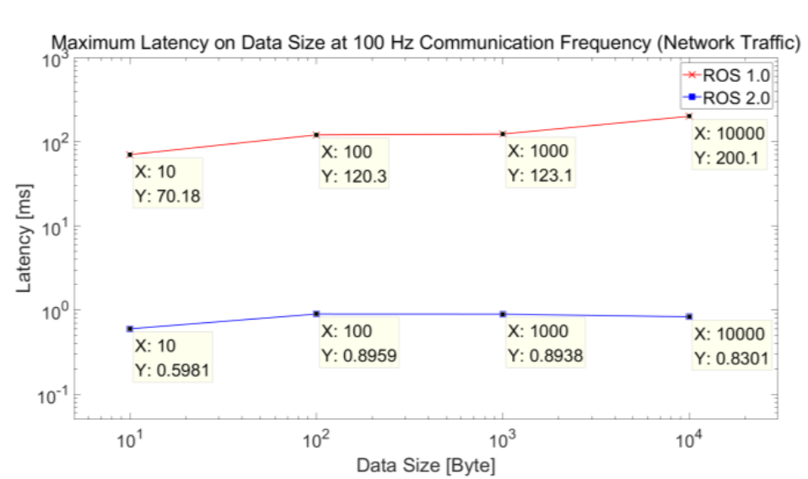

Figure : Maximum communication latency given the data size in environments with network traffic

The outcomes in a dynamic context with network traffic are shown in Fig. 3. The maximum latency was much reduced in ROS 2.0 than in ROS 1.0 in both the steady and idle conditions. While ROS 2.0 demonstrated a little improvement in performance in unreliable situations, latencies in ROS 1.0 made it challenging to transmit and receive messages at the proper time. Additionally, it did not meet the requirements for real-time communication, which makes it challenging to run the system in unsteady conditions.

According to the performance evaluation findings based on data size, ROS 1.0 was unable to meet real-time communication layer requirements and struggled to function properly in unstable environments. The fact that ROS 2.0 has a shorter latency allows it to satisfy these requirements, and because network traffic has a negligible impact on measured performance, steady system operation is achievable even in an unstable environment.

## ROS 2 introduction

The Robot Operating System 2 (ROS 2) is a collection of open source software libraries, hardware driver framework, state-of-the-art algorithms and robust developer tools to develop a control system for robots.

ROS 2 provides us several components for building and developing a robot or a multi-robot system. Some of them are still being developed and improved, thus they are not yet available. This section will introduce the main elements of ROS 2.

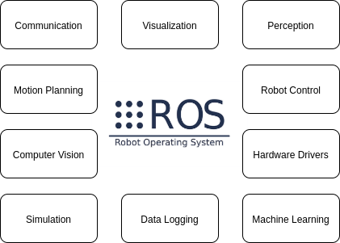

### Communication

# FIRMWARE DESIGN FOR SERVING MOBILE ROBOT

## Raspberry Pi 4B configuration

### Ubuntu version

The project has been implemented at the time that Galactic was the latest release of ROS 2.

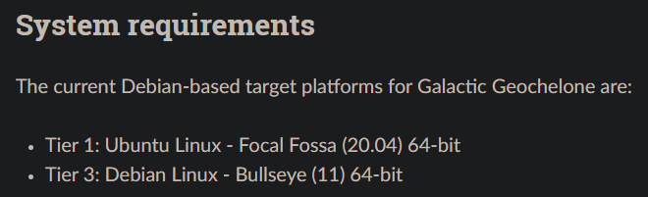

Figure : System requirements from official website for ROS 2 Galactic Geochelone

To have the best support from Operating System, single-board computer Raspberry Pi 4 has Ubuntu Linux – Focal Fossa (20.04) 64-bit installed.

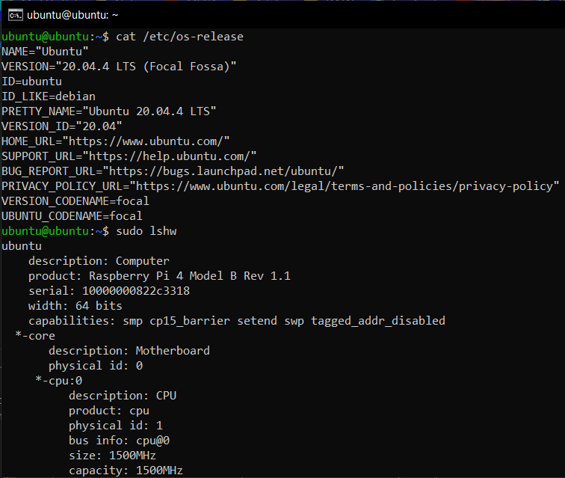

Figure : Ubuntu 20.04.4 LTS on Raspberry Pi 4

### zRAM

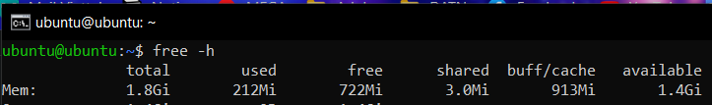

Figure : Initial amount of RAM on Raspberry Pi 4

For this project, Raspberry Pi 4 is the version which has 1.8 Gigabytes of original RAM.

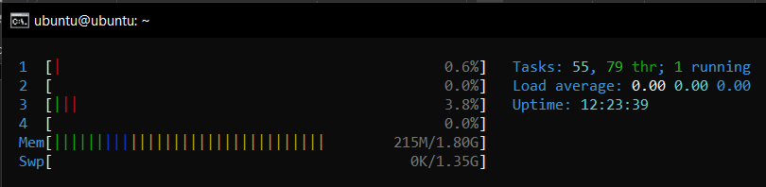

Figure : No-load performance of RAM on Raspberry Pi 4

As observed, when the system is running with no load, the remaining amount of RAM for ROS 2 tasks is 1.4 Gigabytes. During the process of building and running ROS 2 packages, the lag time is quite large and there is a phenomenon where the Raspberry Pi 4 crashes leading to a reboot. To overcome this problem, zRAM was configured for the system of Raspberry Pi 4.

zRam is

THIẾU: https://haydenjames.io/linux-performance-almost-always-add-swap-part2-zram/

### ROS 2 Galactic

### Multiple I2C buses

## Serving mobile robot firmware architecture

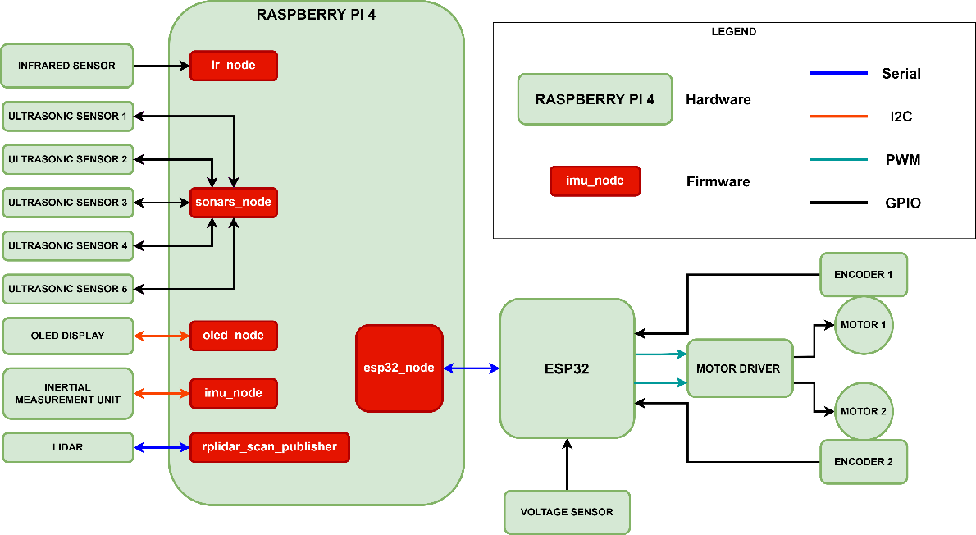

Raspberry Pi 4 and personal computers can both run the ROS 2 system. All of the nodes on the Raspberry Pi 4 are limited to managing peripherals. The other nodes, however, including the SLAM node and the navigation stack, are executed on a personal computer. Each peripheral has an associated node that reads data from the sensor and publishes it to the ROS 2 system.

It takes the right hardware to control motors and receive pulses from encoders, both of which are time-sensitive processes. On the other side, the Raspberry Pi 4 is an inappropriate piece of hardware for applications that need precise timing. The Raspberry Pi 4's RPi.GPIO module is the best option for managing peripherals in Python. It is not, however, appropriate for real-time or timing-sensitive applications. This is due to the fact that Python's garbage collection schedule is unpredictable for developers. Additionally, because Linux is a multitasking operating system and another process could be given priority over the CPU, generating jitter in the program, Linux is not suited for real-time applications. The approach is to use an appropriate microcontroller unit, such as the ESP32 microcontroller, to manage this timing-critical activity. A hardware analog-to-digital converter is also absent from all Raspberry Pi computers. This serves as another evidence that the ESP32, with its 16 ADC pins, is an appropriate MCU for supplying the motor driver with PWM pulses.

## Firmware for motor driver block



Figure : Motor driver block

Motor driver block includes ESP32, motor driver TB6612FNG, 2 motors and 2 encoders. Firmware for this block contains firmware for ESP32 microcontroller and firmware for Raspberry Pi 4.

### Choosing sample time of encoders

THIẾU: giải thích qua về sample time 5 ms, tại sao lại chọn 5 ms (liên quan đến số tick trên vòng và tốc độ động cơ), dẫn đến 1 loạt tham số của serial và loop phải có tần số lớn hơn 2 lần tần số 200 Hz để tránh bị alias (tần số Nyquist)

### Firmware for ESP32 microcontroller

The setup() and loop() procedures are the two primary operations in an ESP32 firmware. When a sketch launches, the setup() function is called. Variables, modes, libraries, and other things are initialized using it. Every time the board is powered on or reset, the setup() code will only be called once. Following the creation of a setup() method, which initializes and sets the starting settings, the loop() function does exactly what it says and performs successive loops, enabling your application to adapt and alter.

#### Setup() function

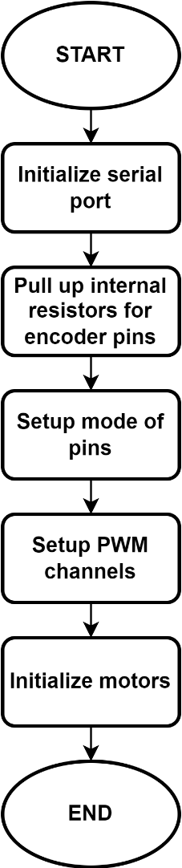

Figure : Flowchart of setup() function for EPS32 firmware

The setup() function includes five successive processes as the Fig. 9. The crucial part in this series of procedures is initializing baud rate for serial port which will be explained later. Pins on the ESP32 microcontroller are configured as input mode or output mode. ESP32's internal resistors pull the input pins, namely the encoder pins, up to a high logic level. By doing this, the pins are prevented from entering an invalid floating condition. The next step is to set up two PWM channels to regulate the speed of the system's two motors.

#### Loop() function

The loop() function includes four vital sections which are receiving data; driving motor; counting pulses, calculating RPM and sending data back to Raspberry Pi 4.

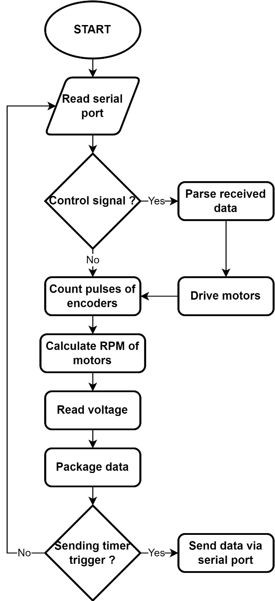

Figure : Flowchart of loop() function for EPS32 firmware

##### Receiving data from Raspberry Pi 4

The data ESP32 acquired from serial port have the form of JavaScript Object Notation (JSON). The form of data for instance can be observed in Fig. 10:

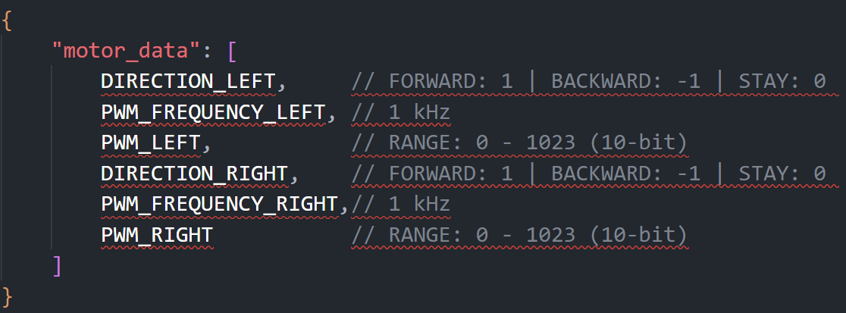

Figure : JSON form of receiving data of ESP32 microcontroller

The direction of the motors is indicated by the direction variable, which has a value of 1, -1, or 0. PWM frequency value selected is 1000 Hz so that the mechanical response of the motor is smooth enough; therefore, there is no sense of tripping due to voltage changes and the motor driver is not overload.

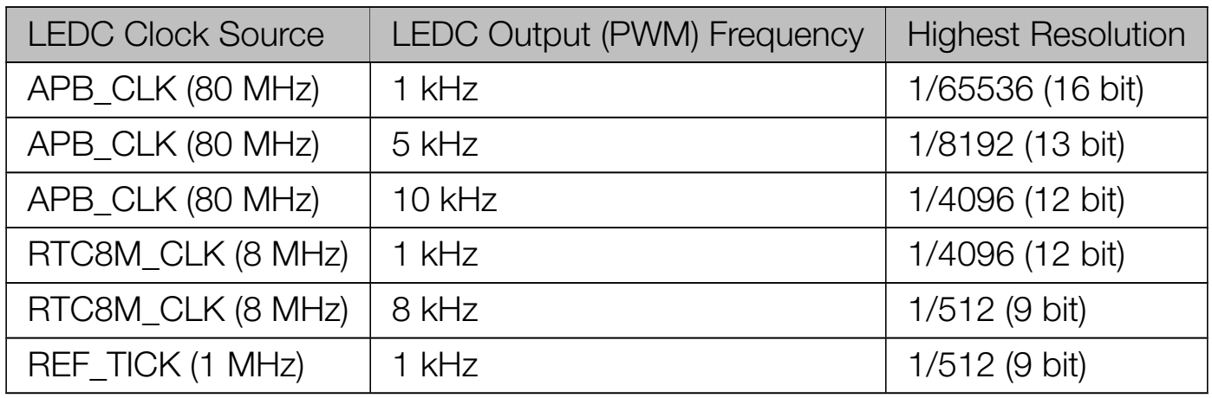

Figure : Commonly­used Frequencies and Resolutions

With a resolution of 10-bit and a PWM frequency of 1 kHz, the motors will operate more smoothly when the resolution is changed between two steps. Moreover, this resolution is within the range of values that make ESP32 works properly as in Fig. 12.

THIẾU: số byte của receiving data, ảnh chụp monitor + tính toán

##### Driving motors

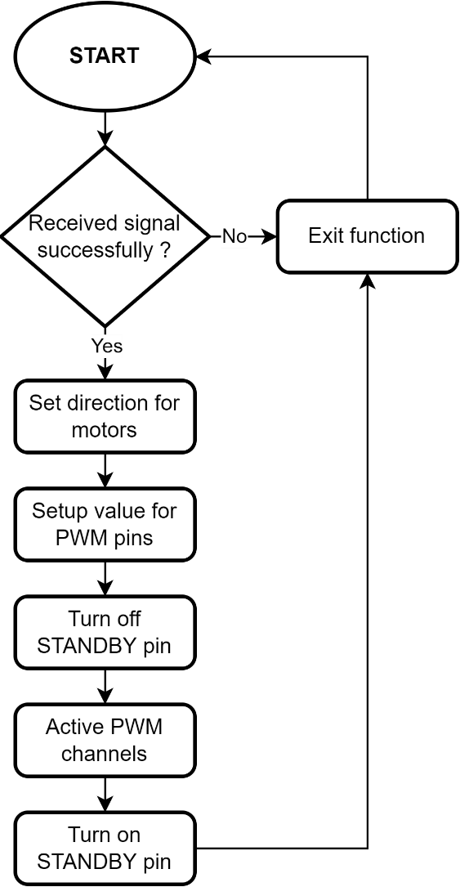

Figure : Flowchart of driveMotors() function for EPS32 firmware

Parsed JSON data will be saved to user-define struct DataReceive before extracted for using in driveMotors() function. With a program, only one line of code can be run at a time. This causes the motor voltage to happen at two different times causing a delay on one side of the motor (Fig. 14). we fixed this by using the STANDBY pin of the TB6612FNG motor driver.

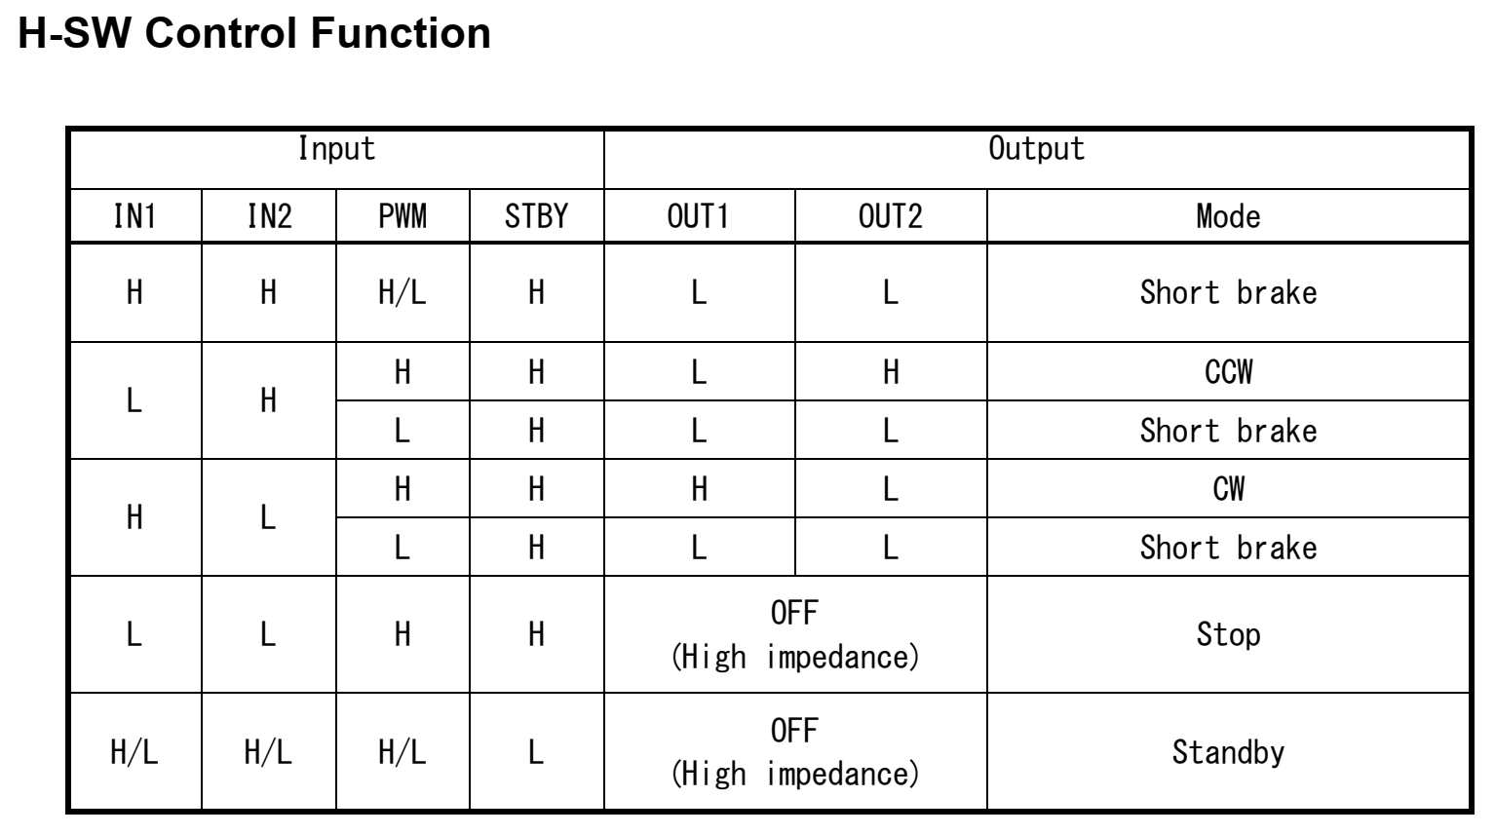

Figure : H-SW Control Function of TB6612FNG motor driver

Both of the TB6612FNG's output PWM pins are disabled while the STANDBY pin is at the low logic level (high impedance mode). The STANDBY pin is switched to a high logic level before the PWM channel value is set using this motor driver function as Fig. 15.

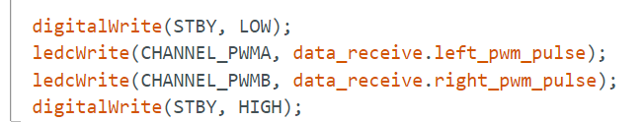

Figure : Solution for instantaneous operating of motors

##### Counting pulses of encoders and calculating RPM of motors

Input signal rising and/or falling edges are counted by the PCNT (Pulse Counter) module. In the module, the ESP32 has several pulse counters. Each unit effectively functions as a separate counter with a number of channels, each of which has the ability to increase or decrease the counter on an edge. We use a C++ library on GitHub by Kevin Harrington to perform pulse reading of the encoders.

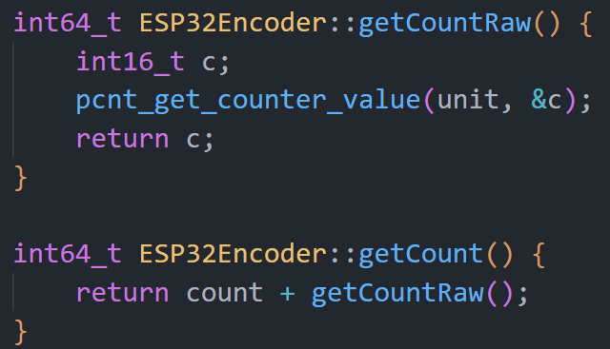

Figure : Block of code for counting pulses in ESP32Encoder C++ library

The function "pcnt_get_counter_value" returns the count value and the "getCount" method of the "ESP32Encoder" class adds the old count value and the new count value to get the current cumulative count value with data type “int64_t” – 64-bit integer.

A user-define class named “RPMCalculator” was written to handle the calculating round per minutes (RPM) of motors.

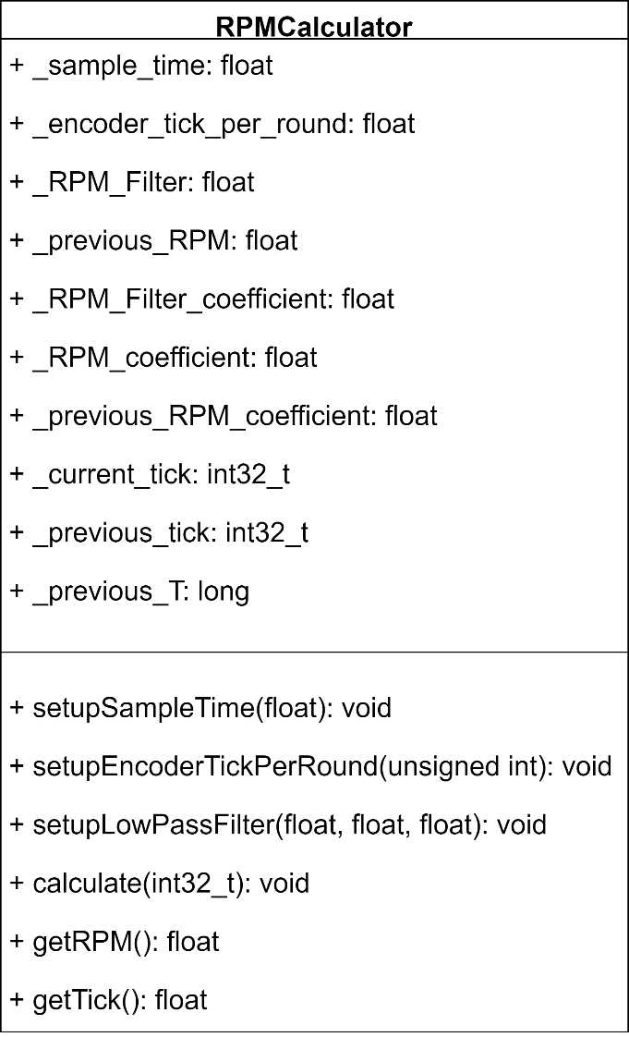

Figure : RPMCalculator class

RPMCalculator class has the primary method which are “calculate”. This method takes one input which is the current pulse of a encoder and update the value of “_RPM_Filter” property. This value then is considered as the current RPM of the motor.

##### Packaging data for sending to Raspberry Pi 4

Data which includes pulses of encoders, RPM of motors are serialized for checksum handling. The system uses MD5 checksum algorithm for data authentication between two serial ports of Raspberry Pi 4 and ESP32 microcontroller. A message of any length can be entered into the cryptographic hash function algorithm MD5, which converts it into a fixed-length message of 16 bytes. This string of checksum value is also added to the JSON string which is sent to Raspberry Pi 4 with the frequency of 500 Hz.

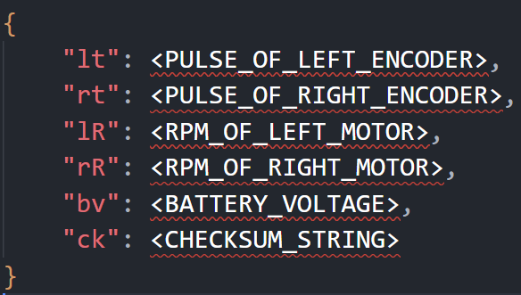

Figure : JSON form of sending data of ESP32 microcontroller

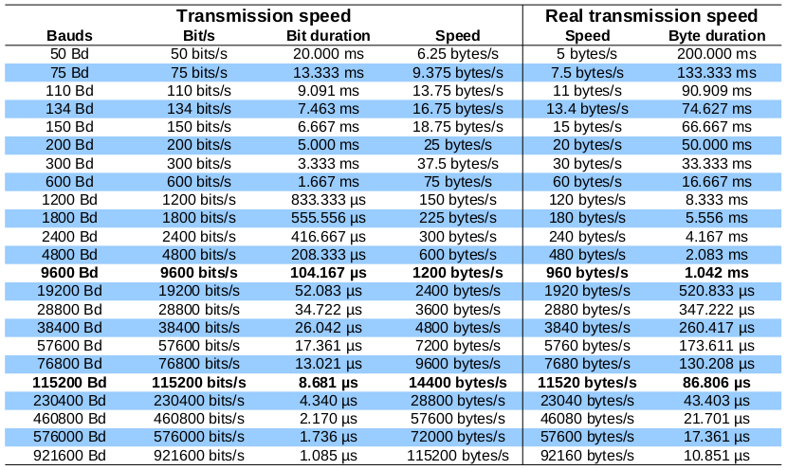

Figure : Transmission speed and Real transmission speed of serial port

## Firmware for ultrasonic sensors

## Firmware for lidar

## Firmware for inertial measurement unit

## Firmware for OLED display

## Firmware for infrared sensor

## Firmware for voltage sensor

# ALGORITHM EXPLANATION FOR FIRMWARE

## PID controller

## Fuzzy logic library

## Kinematic Model for calculating Odometry data

## Kalman filter

## Median filter

# OPTIMIZATION

## Object oriented programming

## Multithreading programming

# EXPERIMENTAL RESULTS

## Comparison of PID controller and Fuzzy PID controller

## Obstacle avoidance using an array of ultrasonic sensors test cases

## Restaurant serving test cases

## Serving mobile robot design result ?

# REFERENCES

|  |  |
| --- | --- |
| [1] | J. Park, R. Delgado and B. W. Choi, "Real-Time Characteristics of ROS 2.0 in Multiagent Robot Systems: An Empirical Study," vol. 8, pp. 154637-154651, 2020. |
| [2] | Espressif-Systems, *ESP32 Series Datasheet,* 2022. |
| [3] | Toshiba-Cooperation, *TB6612FNG Datasheet,* 2007. |
| [4] | S. Kumar, "geeksforgeeks," 21 6 2022. [Online]. Available: https://www.geeksforgeeks.org/what-is-the-md5-algorithm/. [Accessed 21 5 2022]. |

# APPENDIX

1. **Details of experimental data**
2. **Detailed calculation steps**
3. **Detail simulation diagram**